CSC520 Q242 Midterm Exam

*(Part A)*

Due by the end of this class

Name (last, first): Hassan, Sunzid

Total (part A): / 50

*“If you wish to understand you must …”*

# [15 points] Describe how a General Problem can be expressed as a Decision Problem.

A general problem G is a total relation

*G ⊆ I × S*

One or more solutions can be produced for each problem instance. It also called search problem or optimal solution problem. It can be expressed as deciding whether an object is a member of a set,

*[(i, s1, s2,………sn)∈{ (i, s1, s2,………sn): ∀i,i∈I ∃sn,sn∈S(i,sn)∈G}]*

inG = lambda I,ss: all((i,s) in G for s in ss)

A general problem can be expressed as **decision problem** if it has either a yes or a no answer.

A **decision problem** Q is a function Q ⊆ I × {no, yes}

Q : I → {no, yes}

It can be expressed as deciding whether an object is a member of a set

Y = { i ∈ I : Q [i] == yes}

[i ∈ Y] ?

Example:

I = set(range(10))

S = {‘no’, ‘yes’}

I × S = {(i, s) for i in I for s in S}

Q = {(i, s) for (i, s) in I×S if (i%3 == 0 and s == ‘yes’) or (i%3!=0 and s == ‘no’)}

Y = { i for (i, s) in Q if s == ‘yes’}

Input: 4 in Y

Output: False

Every problem can be expressed as deciding whether an object is a member of a set. Every problem can be casted a decision problem.

# [20 points] (a) [10 points] Draw a state diagram for a Turing machine to preform max function that is finding a maximum number from a sequence. The tape is organized as the input sequence of numbers follow by the output _max number. There are 3 possible symbols, i.e. Z = {0,1,2}. *** Note: there are 3 possible symbols, 0, 1, 2 in the input sequence.

# e.g. Input 01211, where read-write head is on leftmost 0. Output 01211_2, where the rightmost 2 is the outputted max number. (When the input sequence is 1100, then the output will be 1100_1, where the rightmost 1 is the max number in the input sequence.) (Note: keep the input sequence the same as given.)

(Part B question 2 py file will be followed this state diagram. That is your part B question 2 py file needs to code your state diagram.)

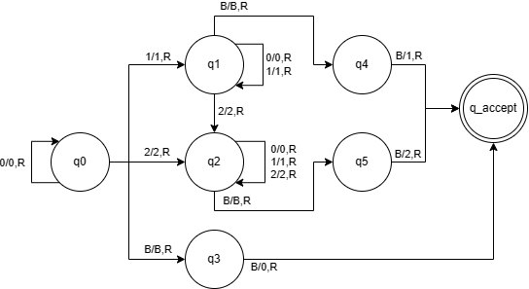

# [15 points] Describe in general what make a problem unsolvable.

Algorithmic problem **unsolvability may** occur only in the case where **infinitely** many cases (arguments of a function, strings of a language) are to be considered.

* e.g. One machine may not predict the behavior of *any* other machines.

When a problem *P* is represented as a function *f*, then:

*P* is **unsolvable** if *f* is *nonrecursive*

When a problem *P* is represented as a set *Sp* then:

*P* is **unsolvable** if *Sp* in *nonrecursively enumerable*